**Lab 4 Activity 1 - Exploring the Interface**

**Objective** - Familiarize students with the MS PowerPoint interface and basic functions, including navigating the Ribbon, using slide layouts, and customizing the Quick Access Toolbar.

1. Open MS PowerPoint and familiarize yourself with the Ribbon, exploring the functionality of each tab (e.g., Home, Insert, Design, Transitions, Animations, SlideShow).
2. Explore the slide layouts by creating a new presentation and adding different layouts (e.g., Title Slide, Section Header).
3. Customize the Quick Access Toolbar by adding frequently used options such as Save, Undo, Redo, and Print.
4. Save the presentation as .pptx and export it as a .pdf. Explore the differences between the two formats and their use cases.

**____________________________________________________________________________________**

**Solutions:**

**Task 1:**

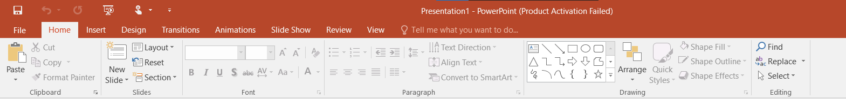

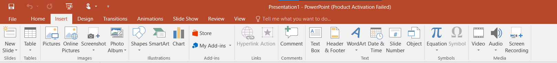





**Task 2:**

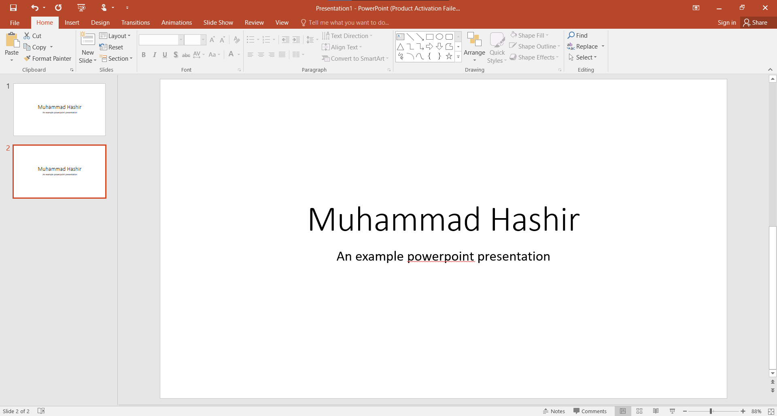

**Task 3:**

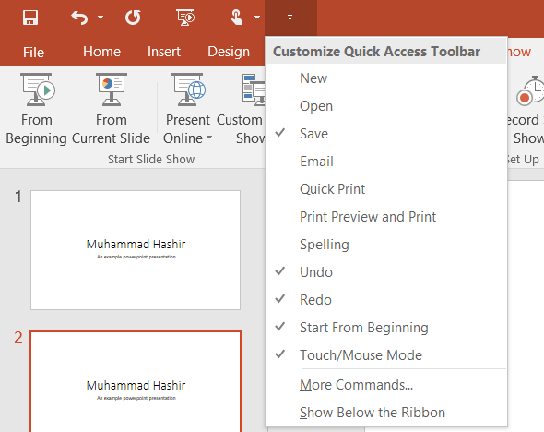

**Task 4:**

* Press Ctrl + S to save.
* To export as PDF, click file, then click export.
* Select PDF.
* Write the name of file and enter.